ANSWER SHEET DAC 2026
PRELIMINARY ROUND



Team Name : _______________

CHAPTER I: Introduction
At the beginning of this document is a detailed explanation of the background of the problem. The background of the problem is described in detail, discussing the issue to be addressed. Participants are expected to be able to determine clear and relevant problem formulation.

CHAPTER II: Theoretical Framework
A. Part of Theoretical Framework
The theoretical framework is an important part of any research as a theoretical basis [1]. In this chapter, participants must select a suitable method aligned with the purpose and type of data to be collected. A concise and accurate explanation according to the method used. These theories will become a reference in analyzing the data obtained. Participants must utilize relevant and credible sources, such as academic journals, books, or previous research findings, to support arguments and analysis. Consequently, a robust theoretical framework provides a solid foundation and facilitates the interpretation of analysis results.
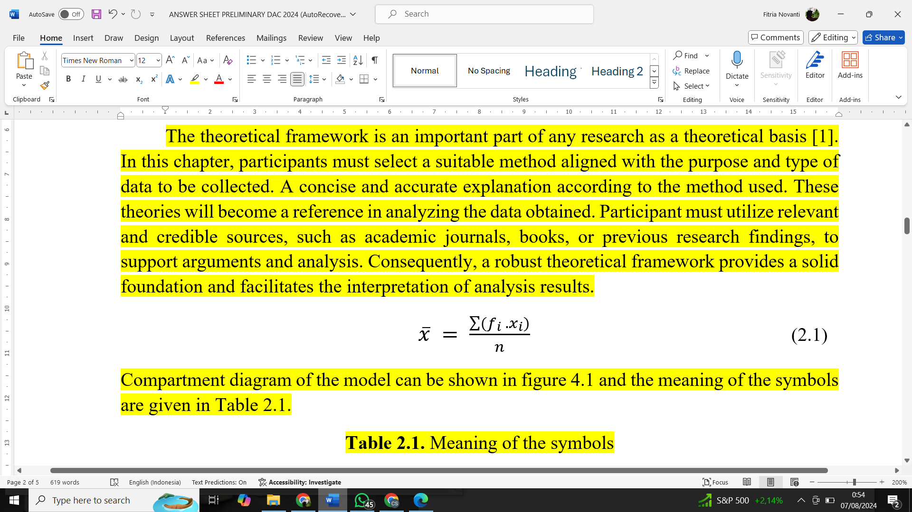
Compartment diagram of the model can be shown in figure 4.1 and the meaning of the symbols are given in Table 2.1.
Table 2.1. Meaning of the symbols
$x̄$ | Mean
$f_{i}$ | Frequency
$x_{i}$ | A Specific Observation
n | The Amount of Number

CHAPTER III: Analytical Steps
This chapter provides a detailed description of the data analysis process. The participant will present a systematic and logical sequence of steps with comprehensive explanations. Readers will be able to understand how the participant transforms raw data into meaningful and defensible information. The presented analytical steps will also demonstrate the validity and reliability of the analysis [2].

CHAPTER IV: Analysis of Results
In this chapter, participants are expected to carry out a structured analysis of the dataset and present meaningful findings. The analysis may include steps such as data preprocessing (cleaning, tokenization, stopword removal, handling of short texts), exploratory data analysis to identify class distributions or trends, model development and evaluation using appropriate techniques and metrics (for example regression or classification models with RMSE, MAE, R², or Macro F1 as relevant), as well as interpretability and feature importance analysis. Participants are also encouraged to generate insights from the data, such as identifying recurring patterns, exploring differences across groups (e.g., app versions, genres, or time), and linking observed results to potential business or user experience implications. Visualizations, statistical tests, and comparative analysis may be used as supporting evidence, but participants are free to structure and expand their report in a way that best conveys their insights and recommendations.

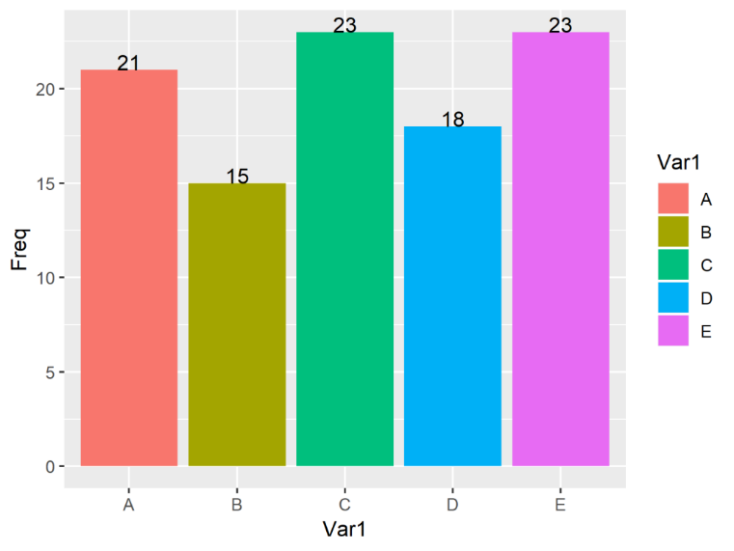
Figure 4.1. Barchart diagram
This means that the most data points or observations were collected from province C and E. It could represent the highest population, the greatest number of events, or any other variable that is being counted. Beside that, based on Attachment 1 we can see that each province has a range from highest to the lowest average values. These results can be used as a reference for determining the clustering.

CHAPTER V: Conclusion and Recommendation
The final stage of analysis involves summarizing the key findings and providing actionable suggestions. This chapter begins with a clear and concise summary of the analysis results, synthesizing the main insights derived from the data analysis. The conclusions are drawn with clarity, ensuring they reflect the evidence presented, while the recommendations are practical and tailored to the needs identified during the research [3]. This chapter is essential for translating research outcomes into meaningful guidance for stakeholders and future research.

REFERENCES
(IEEE Style, Times New Roman, Font 12)
[1] | J. L. Rosenberg och L. M. Epstein, Schaum's Outline of College, New York: McGRAW - HILL, INC, 2000.
[2] | R. Chang och J. Overby, General Chemistry; The Essential Concepts, New York: Mc-Graw Hill, 2011.
[3] | N. D. Jespersen, J. E. Brady och A. Hyslop, Chemistry: The Molecular Nature of Matter, Hoboken: John Wiley & Sons, Inc, 2012.

ATTACHMENT
Attachment 1: Barchart Diagram
